**BONAFIDE FORM FOR STUDENT**

**(ABESEC/2021-22/Deptt./SID- )**

Complete and submit this form to your department. Type or write clearly in **UPPER** Case.

|  |  |  |  |  |
| --- | --- | --- | --- | --- |
| 1. Student Name: | **Archit Saxena** | | Roll No: **1803221023** | Sem./Sec:  **8th/A** |
| 2. Home Address: | **H.N-113,azad nagar ,railway harthala colony, Moradabad-244001** | | | Mobile No:  **8433063012** |
| 3 Student email-id: **archit.18ben1003@abes.ac.in** | | | | |
| 4. Academic Result (Semester wise %)  I Semester: **86** IV Semester: **85.2**  II Semester: **77.4** V Semester: **78.1**  III Semester: **78.5** VI Semester: **86.2** | | | 5. Semester/Year  **8th /final year(2022)** | |
| 6. Internship/Training Details: Capgemini internship | | | | |
| Company Name:  **Capgemini** | Company with address:  **Capgemini** | Start Date  **9th February** | End Date  **2nd May** | Position  **Analyst** |
| Note: I, hereby declare that I   * Have opted elective subjects: * Will provide the monthly attendance to my class coordinators, verified by company’s HR. * Will appear in ST-1, ST-2 & PUE as well as assignment (TA) as per the academic calendar. * Will present my seminar & project presentation as per schedule. * Will fill university exam form & exam fees within time as per university guidelines. * Will appear in university examination without any fail as per the schedule. * Will be student’s responsibility for syllabus coverage as per requirement of university curriculum. | | | | |
| **Student Signature: ARCHIT SAXENA Date: 12/02/2022**  Signature confirms that the student agrees to all terms & conditions, and other requirements of the academics. | | | | |
| **Faculty mentor Signature: Date .**  **Faculty Coordinator Signature: Date .** | | | | |
| **Deptt. Coordinator (Placement) Head-CCPD HOD Director** | | | | |

### ATTENDANCE SHEET

**ABESEC/2021-22/Deptt./SID- )**

Name & Address of Organization

|  |  |  |  |
| --- | --- | --- | --- |
| Name of Student |  | | |
| Roll. No.: |  | Mobile No.: | |
| Name of Course |  | | |
| Date of Commencement of Internship/Training: | | |  |
| Date of Completion of Internship/Training: | | |  |

#### Initials of the student

|  |  |  |  |  |  |  |  |  |  |  |  |  |  |  |  |  |  |  |  |  |  |  |  |  |  |  |  |  |  |  |  |
| --- | --- | --- | --- | --- | --- | --- | --- | --- | --- | --- | --- | --- | --- | --- | --- | --- | --- | --- | --- | --- | --- | --- | --- | --- | --- | --- | --- | --- | --- | --- | --- |
| Month & Year | 1 | 2 | 3 | 4 | 5 | 6 | 7 | 8 | 9 | 10 | 11 | 12 | 13 | 14 | 15 | 16 | 17 | 18 | 19 | 20 | 21 | 22 | 23 | 24 | 25 | 26 | 27 | 28 | 29 | 30 | 31 |
|  |  |  |  |  |  |  |  |  |  |  |  |  |  |  |  |  |  |  |  |  |  |  |  |  |  |  |  |  |  |  |
|  |  |  |  |  |  |  |  |  |  |  |  |  |  |  |  |  |  |  |  |  |  |  |  |  |  |  |  |  |  |  |  |

**Terms & Conditions:**

1. Concerned department of the company shall provide the attendance of student by 4th Saturday of every month through official id of company or official letter head of company to respective faculty mentor.
   * Attendance Sheet should remain affixed in Daily Training Diary. **Do not remove or tear it off.**
   * Student should sign/initial in the attendance column. Do not mark ‘**P**’
   * Holidays should be marked in **Red Ink** in attendance column.
   * Absent should be marked as **‘A’ in Red Ink.**
2. Student must submit a report about the project he/she is working on (compliance with the company policies).
3. Faculty mentor must take a review from company on monthly basis and must keep record
4. Agreement/confirmation for granting leave for any examinations, practical and project presentations.
5. College/department academic calendar to be shared with company along with NOC.

#### Signature of reporting manager with company stamp/ seal

(Name_____________________________________) & Mobile No: ___________________

Process flow

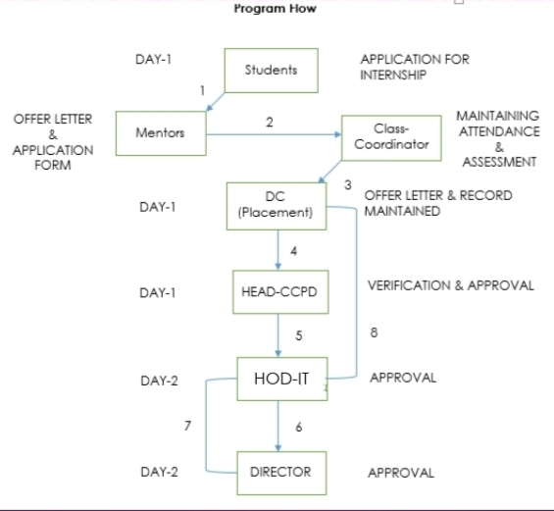



1. Mark sheets (Ist to VIth Semester).
2. Placement offer letter copy.
3. Joining notification from company.
4. Bonafide form for Student **(ABESEC/2021-22/Deptt./SID- )**
5. Attendance sheet is to be submitted on **4th Saturday of every month** verified by HR & submitted to class coordinator
6. Student to give **consent/permission letter from parents** (duly signed).
7. Student to give **consent/permission letter from parents** (duly signed) **for staying outside hostel,** if applicable.



**Role & Responsibilities**

**Role & Responsibilities**

**Role & ReResponsibilities**

**Role & ReResponsibilities**

* **Students will submit** - (Bonafide Form for Student, Marksheets’ copy, Company’s offer letter copy, Joining notification & Monthly attendance sheet.
* **Mentors -** Collect the offer letter & application form.
* **Coordinators -** Maintaining attendance & assessment (Class test / Presentation)
* **Department Coordinator -** Offer letter confirmation & record maintenance.
* **Director office/Registrar office: Issuing of Bonafide Letter (Registrar Office).**